**CitiBike Analytis Report**

**Background:**

Since 2013, the Citi Bike Program has implemented a robust infrastructure for collecting data on the program's utilization.

Now, its our objective to show you how these Data can be useful to visualize the results on efforts implemented during these periods.

**Data Range:**

From september 2015 to June 2019

**Goal:**

Build a dashboard, story or report using selected timespan to oversee the behaviour of the bike sharing program of NYC.

**Story Report**

To make these results more clearly and easy to understand. Let’s start with the data collected since last 2015.

**How has this program been successful since 2015? Has it been succesful?**

It seems, that from september 2015 to June 2019, people have been more satisfied with the program. People might be spreading the information about the benefits or facilities the program has brought to their lifes.

Since then, there has been more and more rides. More rides suggest that more people are using the service, or the same person is using the service more times a day.

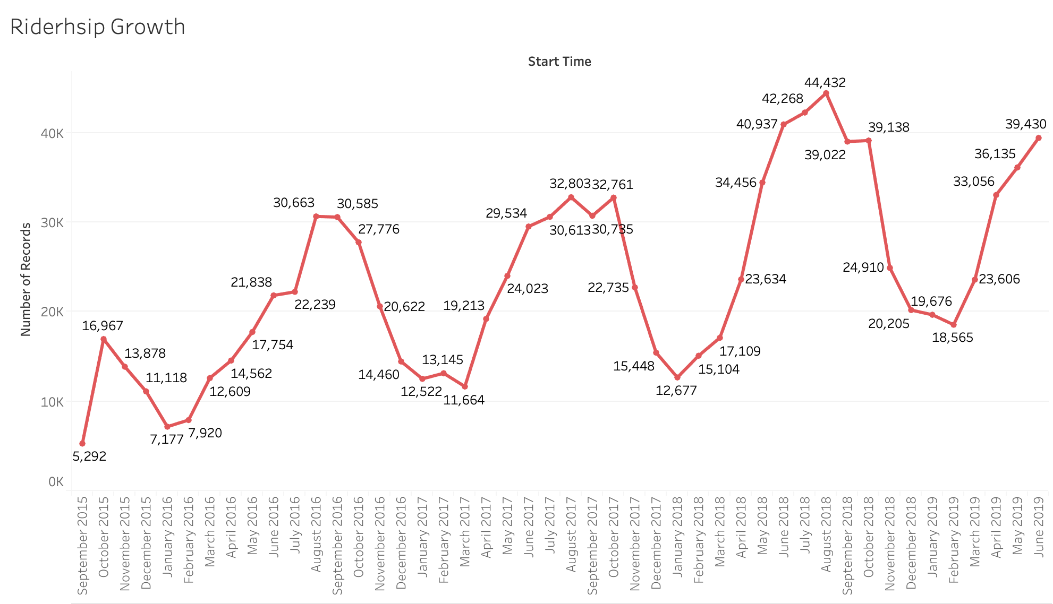

**What about year seasons?**

Let’s see a more detailed analysis about this program. When do people prefer to make use of the service? Is it summer? Is it winter? Next graph suggests the first.

Because it is more pleasant to ride a bike on summer, rather than winter days. Imagine yourself trying to ride a bike with half a meter of snow on the streets.

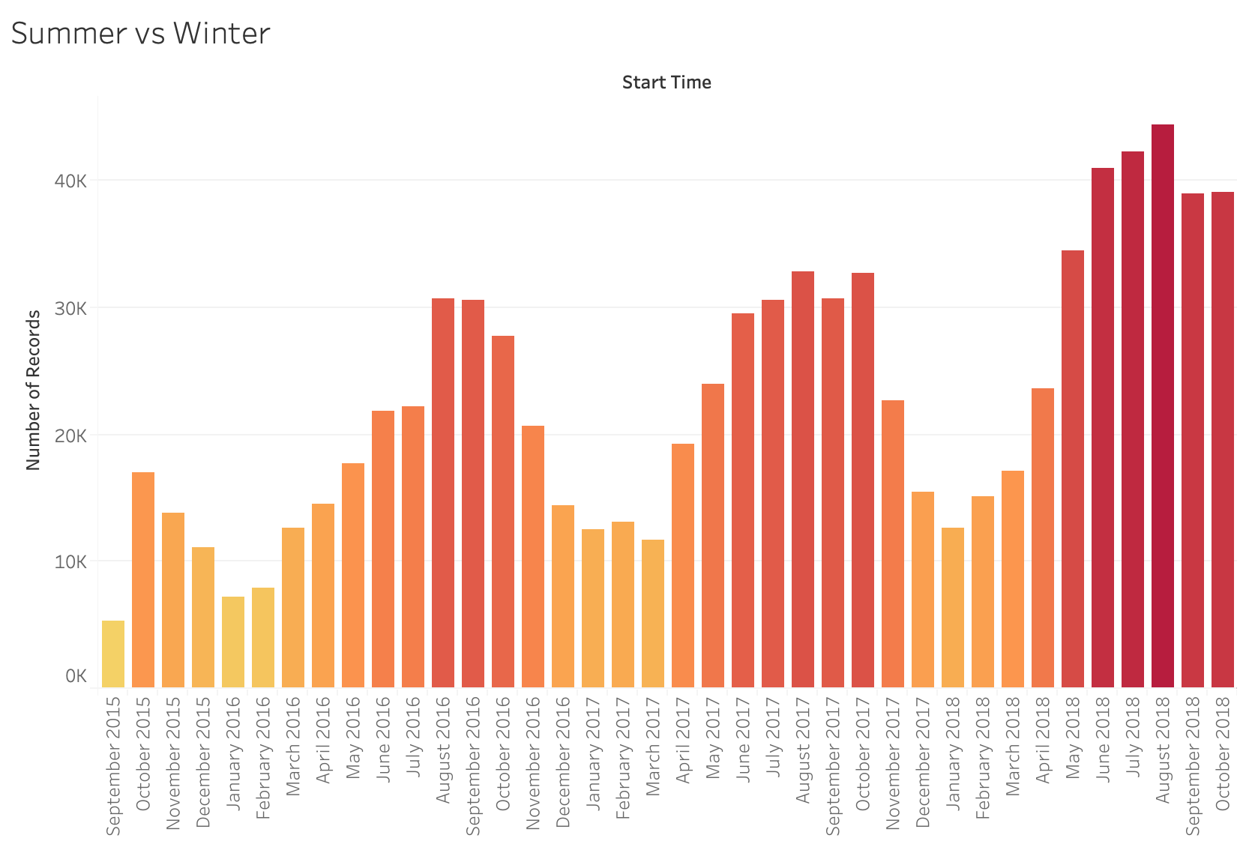

**Which one would you prefer?**

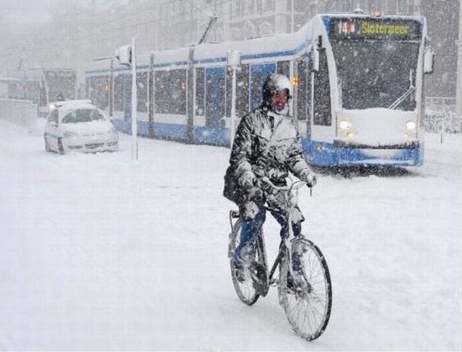 

Surelye, most people would pick the second one? And these graphs shows that those people think probably the same.

But which are the reasons that make people reduce the bike riding on winter days?

It is probably more dangerous to ride a bike in winter than in summer. It is also probably that those people do not go outside often during those days, staying home doing home office or it is safer and warmer to take the public transportation.

**And now, who are the ones that prefer this sharing program?**

On June 30th, the more people that made use of the bikes program were the Males, followed by Female.

In general, during all this period there were more men riding the bikes.

|  |  |
| --- | --- |
| **Rides on June 30th per gender** | **All rides per gender since 2015** |
|  |  |

**And, subscribers?**

So far, there are many subscribers, and clearly they are the most common people using the service, rather than ocassionally customers or one time riders, maybe tourists, or not so often users

|  |  |
| --- | --- |
|  | There is a total of 1, 035, 953 subsribers to the program, in this period.  For a 3 years period, this could be significantly good because at the same time the increasing use of the ride service is also meaningful. |

**Now, which is the best place to start and end a ride?**

This is important to know and see. These might tell us if we need to increase the number of bikes available for the people, as there is also an increasing number in these rides and subscribers.

Both of the next graphs shows some interesting facts in common. First, the same place to start a ride is the same place to end it. And the difference between the first and the second is significantly great. Practically a third of the rides on that station. Althoug this is only on june 30th. The trend shows that this station is the most common one to start a ride. We’ll see that on the map in the next pages.

But this will be a good idea of where we can put more available bikes in a near future.

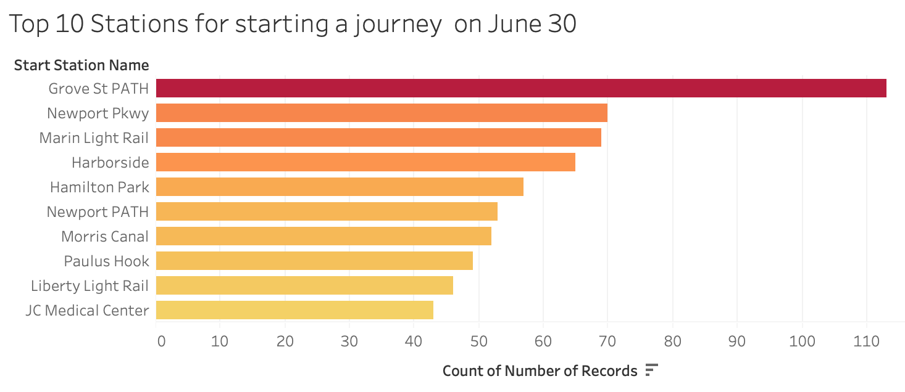

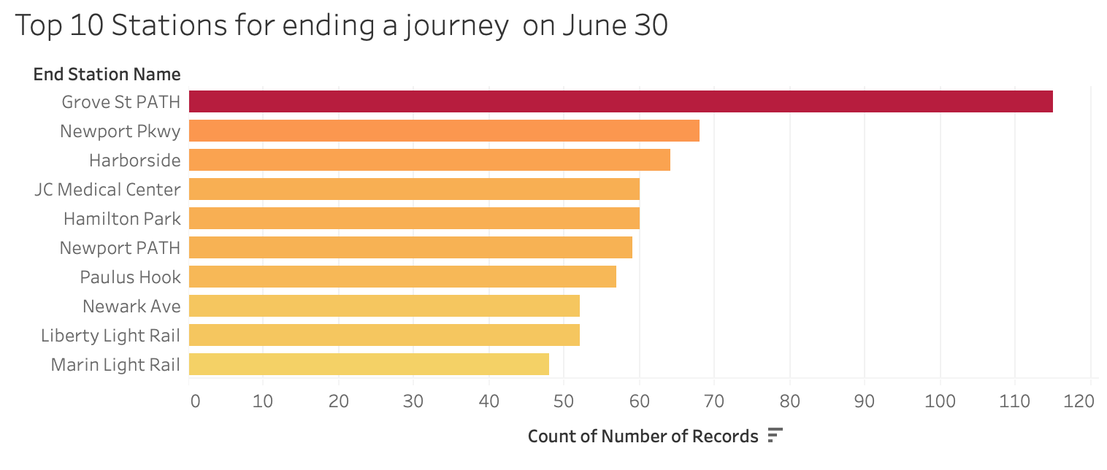

So the next map is a reference for all the timespan in the data set selected of where is the favourite or the most common place to start a journey. That place belongs to the red spot in the map. While the orange spots shows the second best places to do so. The blue spots shows the least common places to start a journey. So we could thell, from this map, that the most common places to start a journey are most of them close to each other.

In this map, the Count of Start Station ID, shows the full number of rides started on that Station.



**What about the least common stations?**

Now, we can see that the least common station to start and end a journey is JCBS Depot.

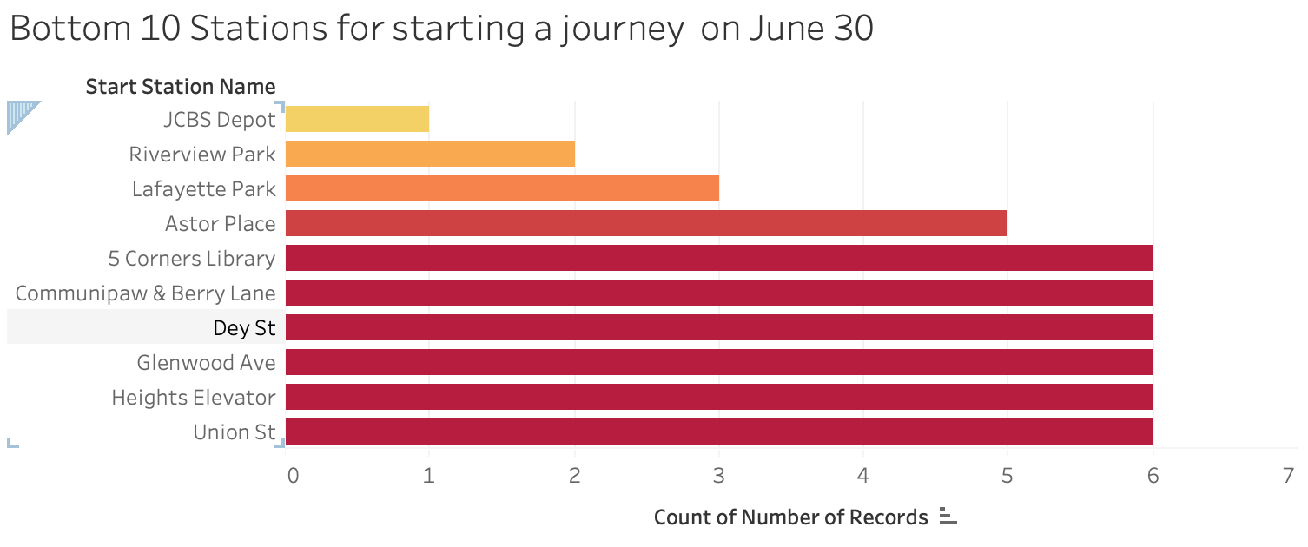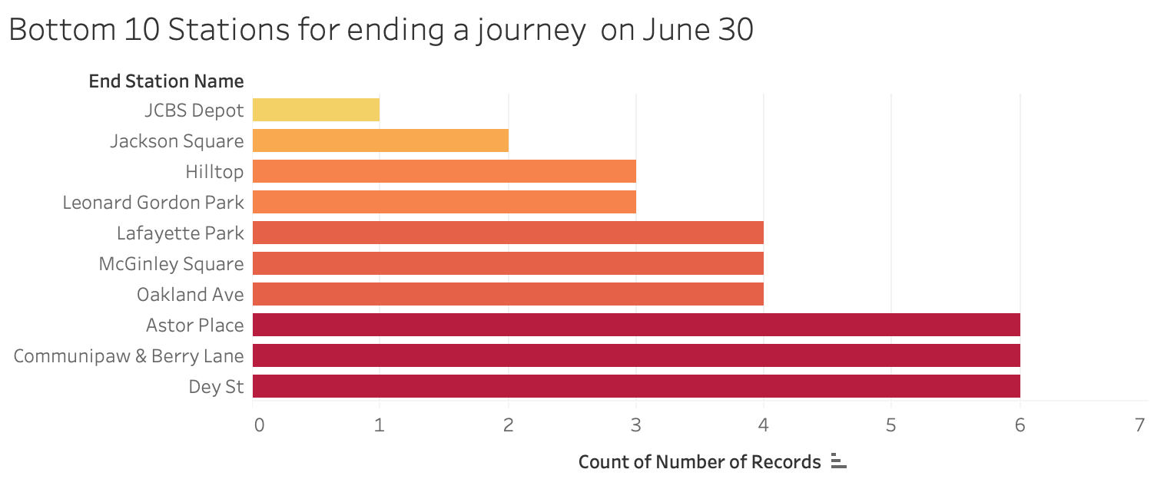

More than that, from the map, we can see that there are more stations to end a journey, clealry seen on the other side of the bay. Maybe because they ride far and come back by public transportation. A deeper analysis into public transportation might be necessary to analyse this interesting fact. Because we can’t see many starting stations on the same spots than ending stations map show.



**Zip Codes?**

We can see the most common stations to start a ride by zip code. This station is Grove St Path which Zip Code is 03186. Remember from the analysis we have made that this station is also the most common one to end a journey.

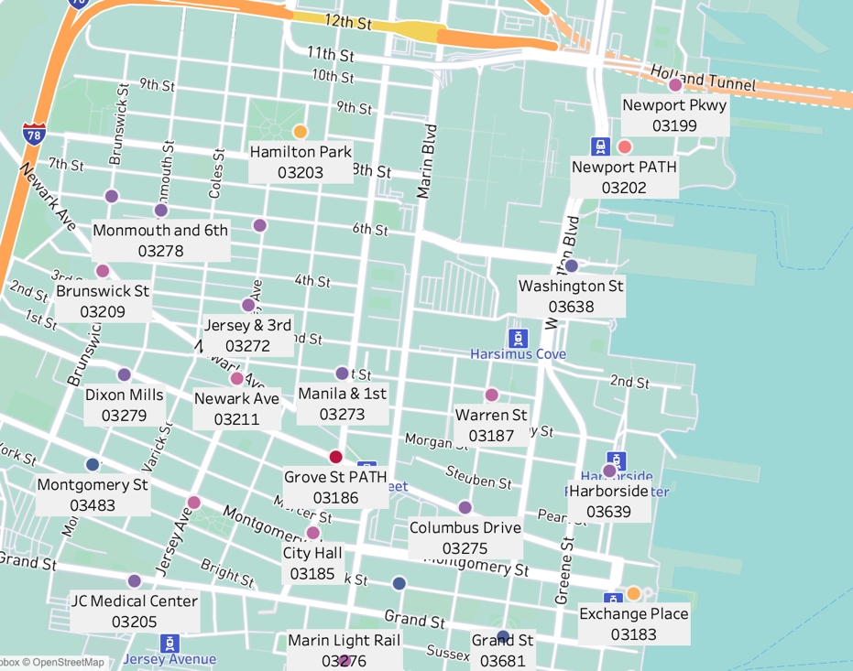

**Not everyting is joy?**

It is known that bikes need maintenance, this means we’ll need to repair often the bikes of the sharing program. But how could we know which bikes needs repairings or might need in the future. We can tell that by knowing which bike or bikes have had more rides. These are the top 10 bikes with more rides, and we can see that, in this data, thee is on bike with the most rides. The graph shows the amount of hours the bike has been used.

